Literature Review
Load testing is vital to proving that web services meet the demands of its users, both in traffic and behaviour (Draheim et al., 2006). It Helps to locate issues in the code that might not appear under smaller load. These are errors are called “Load sensitive” (Bayan and Cangussu, 2006), and stamping them out is vital to robust web service hosting.
The rate at which transactions are conducted constitutes “load”. Sending this to a target for test purposes, constitutes a “load test” (Bayan and Cangussu, 2006). Workload (characteristics and intensity), environment and, high-level metrics also define a load test and its results (Malik, 2010). Stress Testing is similair to workload, however the express intention is to break the system, and to verify how it recovers (Bayan and Cangussu, 2006). Intensity refers to arrival rate and throughput of data (Malik, 2010). All of these come together in a test report (Malik, 2010).
Simluating the internet proper is near impossible, due to its shear scale, impracticality and the number of nodes needed (Sumeet Kumar and Kathleen 2017), but, it is certainly possible to create software that facilitates the entire load testing process. And to make the results it obtains far more accurate (Yan et al., 2014).
Current tools support simple test cases with a fixed sequence of actions (Draheim et al., 2006) Mercury Interactive's LoadRunner current load testing leader (Draheim et al., 2006). Current software are only client-server models and offer only a limited number of scenarios (Bhatia et al., 2014). DITG, Harpoon, fudp, 2Hping and, curlLoader are currently available open source traffic generators (Bhatia et al., 2014) Curlloader is relatively flexible in its use compared to the others (Bhatia et al., 2014). LoadUI, ApacheJmeter IBM Rational Performance Tester are other available load testers(Yan et al., 2014). Testmaker is another WS load tester that allows concurrency testing on Amazon EC2 (Yan et al., 2014). SURGE calculates how a user might interact with a website based on what's on each page (Hasenleithner and Ziegler, 2003).
Tests often need to be parameterised and modified and this can be very hard to do. More advanced tools and knowledge are often needed to perform these changes to tests (Draheim et al., 2006). How Load test analysis are performed has been investigated before (Malik, 2010), even going as far as investigating whether such tests being machine generated based on behaviour observation is viable (Bayan and Cangussu, 2006).
As software shifts towards being offered “-as-a-service” (-aaS), offering some sort of “load tester as a service” (LtaaS) would be wise, and allow for some future proofing. A Load tester will likely contain four major components(Yan et al., 2014):
- Test Receiver: Receives tests to run from the tester, can also monitor tests.
- Test Manager: Manages queues fo tests and dispatches them, gathering and merging test results.
- Test Runner: Invokes the tests and also analyses the validity of the results.
- Middleware Manager: provides and amanges testrunners for use within the system
Whilst these are only possible avenues for components and oeprability for the software, they none-the-less show that this is a problem that has had thought and effort put into it before.
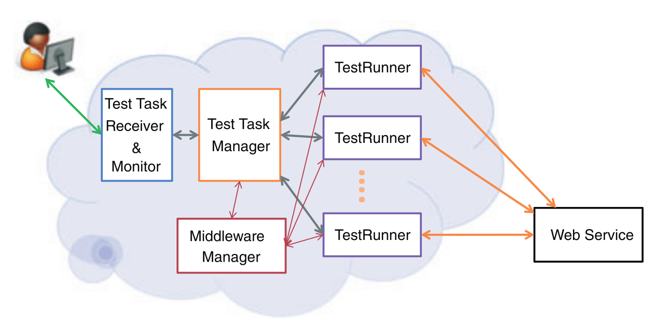Figure 1: Theoretical layout of a web-service (Draheima and Weber, 2005)
Artificial traffic generation is often the only practical way to really verify the running of a service. Hardware traffic generation often leads to greater packet drop at the target but itis faster than a software solution however, it also comes at a greater cost. Also, generating precise traffic allows much greater control (Bhatia et al., 2014).
Load testing should be performed regularly to make sure that resources are correctly provisioned (Draheim et al., 2006). Different Modes need to be offered for proper testing; Static, step and maximal testing are three such methods. Static runs for a specific load. Step runs for measuring usability under a load span. Maximal load to determine upper limits (Yan et al., 2014).
Real user data can (and should) be used to model traffic. However, such models are less versatile than stochastic ones. Script driven approches are common, but visual editors massively increase usability (Draheim et al., 2006).
Reconfigurability for a variety of connections. Low cost, low resource would be a signifcant boon, however using the resources as efficiently as possible is key. Traffic load co-ordination would also help to improve results and efficency. Traffic aggregation would also be beneficial to make sure all traffic acts on a single interface at the target. Monitoring the traffic is also a good feature to have (Bhatia et al, 2014).
Another structure would involve: Input identification, controller tuning and a controller. Input Identification involves finding inputs that affect the resource of interest. Controller tuning involves figuroing out the internal parameters of the chosen controller. The controller itself drives the testcases to what load level is wanted. (Bayan and Cangussu, 2006).
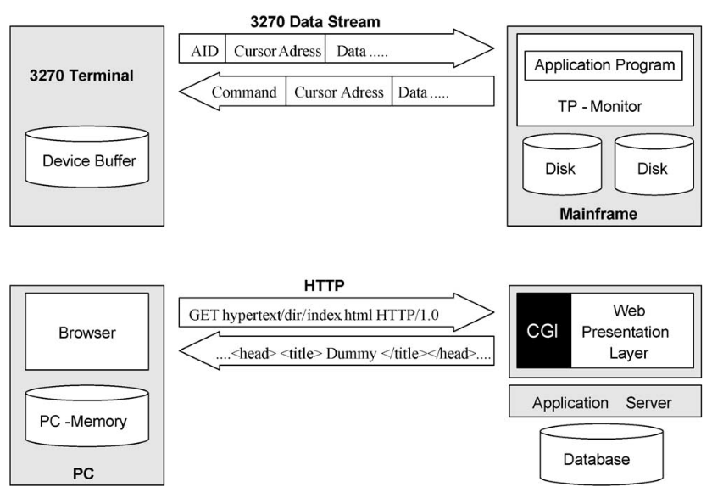Figure 2: Examples of ultra-thin client based submit/response style systems (Draheima and Weber, 2005).
Pseudo random generators are potentially very good for the purposes of this program (Akhshani et al., 2017), while on one hand we need tests to be identical every run to gauruntee that the tests are valid, it can offer some more specialised testing for tests tha tmight run for an entire day, possibly detecting memory leaks and other load sensitive bugs that might only appear under such conditions. The algorithm for constructing a random number generator based on quantum chaotic maps can also be used to create a good chaos model from which to work. Only using user activity graphs instead, to better try to model peak times. (Akhshani et al 2017) User interaction can be modelled as a bipartite state transition diagram (Draheim et al 2006).
Geographically distributed instances would improve the results per test task. Large amounts of concurrency within each instance would be good as the loads can be very large, and the taffic could be very high (Yan et al, 2014).

